**Lab6. Creating Triggers**

1. Create at least three triggers with the functionality according to the database subject area.
2. Demonstrate the results of triggers functioning.

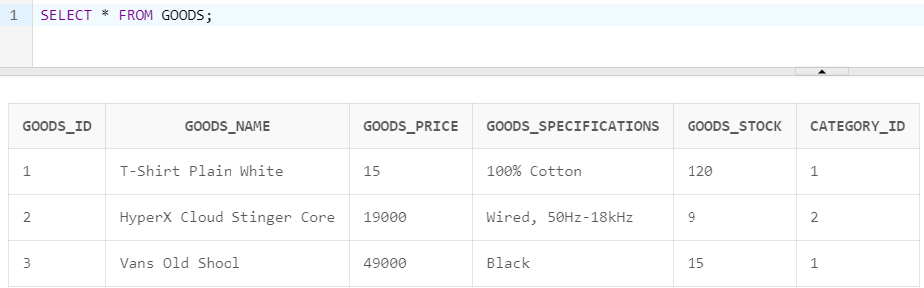

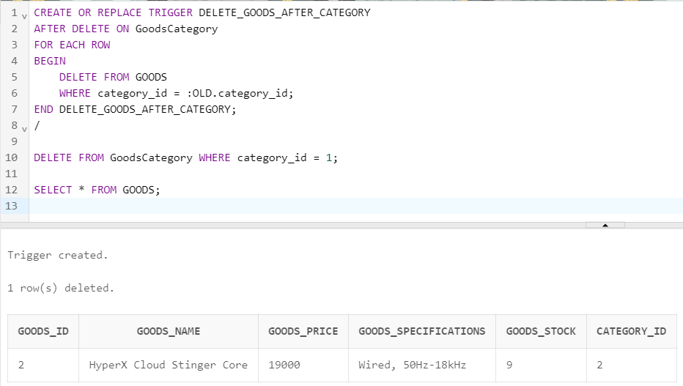

CREATE OR REPLACE TRIGGER DELETE_GOODS_AFTER_CATEGORY

AFTER DELETE ON GoodsCategory

FOR EACH ROW

BEGIN

DELETE FROM GOODS

WHERE category_id = :OLD.category_id;

END DELETE_GOODS_AFTER_CATEGORY;

/

DELETE FROM GoodsCategory WHERE category_id = 1;

SELECT * FROM GOODS;

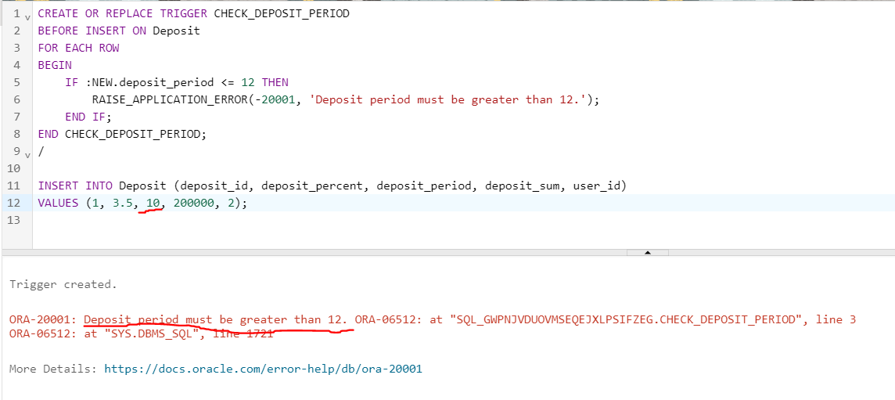

CREATE OR REPLACE TRIGGER CHECK_DEPOSIT_PERIOD

BEFORE INSERT ON Deposit

FOR EACH ROW

BEGIN

IF :NEW.deposit_period <= 12 THEN

RAISE_APPLICATION_ERROR(-20001, 'Deposit period must be greater than 12.');

END IF;

END CHECK_DEPOSIT_PERIOD;

/

INSERT INTO Deposit (deposit_id, deposit_percent, deposit_period, deposit_sum, user_id)

VALUES (1, 3.5, 10, 200000, 2);

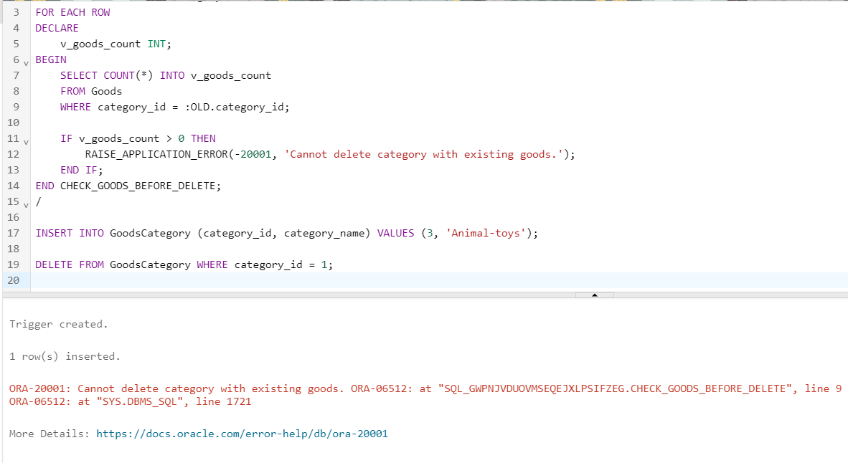

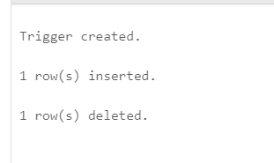

CREATE OR REPLACE TRIGGER CHECK_GOODS_BEFORE_DELETE

BEFORE DELETE ON GoodsCategory

FOR EACH ROW

DECLARE

v_goods_count INT;

BEGIN

SELECT COUNT(*) INTO v_goods_count

FROM Goods

WHERE category_id = :OLD.category_id;

IF v_goods_count > 0 THEN

RAISE_APPLICATION_ERROR(-20001, 'Cannot delete category with existing goods.');

END IF;

END CHECK_GOODS_BEFORE_DELETE;

/

INSERT INTO GoodsCategory (category_id, category_name) VALUES (3, 'Animal-toys');

DELETE FROM GoodsCategory WHERE category_id = 3;

Questions:

1. What are triggers for?
2. What are the types of triggers depending on the execution time?
3. What are the types of triggers depending on triggering events?
4. Describe statement level triggers with examples.
5. Describe row level triggers with examples.
6. What is the sequence of execution of statement and row triggers?
7. Describe **new** and **old** qualifiers, and their structure.
8. What is the section WHEN for?
9. How a trigger is created.
10. How the triggering events can be grouped?
11. When INSTEAD OF triggers are used?
12. How to create a disabled trigger?
13. How to enable or disable a trigger?
14. What is a mutating table?
15. What is a compound trigger?
16. In which sequence the sections in a compound trigger must be defined?
17. How to create a compound trigger?
18. For which database objects can a compound trigger be created?